# Import Export Models in Dynamics AX 2012 without Windows PowerShell or AXUtil – Model Import Export Wizard

A ***model*** is a set of elements in a given layer. Each layer consists of one or more models. Models can be exported to files that have the **.axmodel extension**. These files are called **model files**. Model files are deployment artifacts that can be imported into a model store.

## Challenge

Many a times we face requirements of **migrating models** from one environment to other, especially from test to production or vice a versa. The only solution currently available is to use **AXUtil tool or WindowsPower shell,** which will expect you to write line commands for doing this. What if you don’t know the commands? What if you the developer is not present to provide you needful information? In that case, even after completion, you won’t be able to deliver.

Even, for those of you who have been working on AX 2012 and have been using the **AXUtil tool or WindowsPower shell cmdlets** for importing, exporting models, you’ve probably run into a significant amount of frustration in remembering the cumbersome commands, closing and opening the AX environment multiple times.

This all leads to the inevitable question: **Why didn’t AX2012 ship with some sort of visual interface to accomplish Model management?**

## Solution

How about a wizard with a simple GUI lets you do the same with relative ease? That’s exactly what we are going to present you: **A Model Import Export wizard for Microsoft Dynamics AX 2012.** The best thing about this is that, **it’s so simple.** Imagine in three mouse clicks, your model will be exported to your desired location. Similar is the case with import. You would not be asked to type a single command. This will make your **model migration fast and simplified**.

## Key Features

* Simple GUI for import and export models
* No need to close AX client now
* Faster than AXUtil and WindowsPowerShell
* Filter model based on layers
* Minimum steps and availability within AX environment.

Moreover, it’s available for you in the development environment itself, so **no need to close the AX client** as the case was with AXUtil and Windows PowerShell.

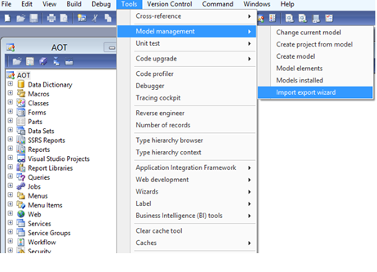

Having such a tool would led to a hassle free development and will leave you free off migration tension.

## Steps to install the tool

* Import the XPO project in your AX environment.
* Once import is done, restart your AX client.
* You can find the wizard under Tools->Model Management->Import Export Wizard, in the Development Workspace.

## Export Using Wizard

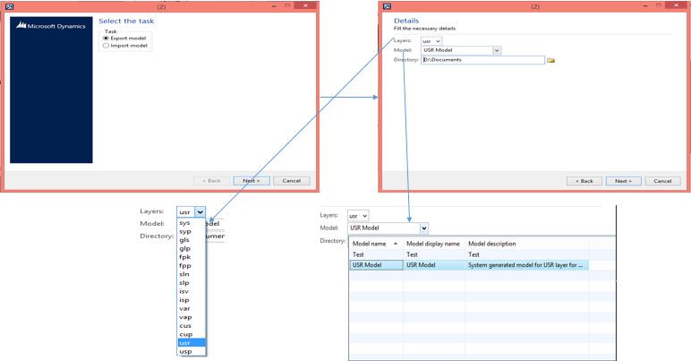

## Import Using Wizard

